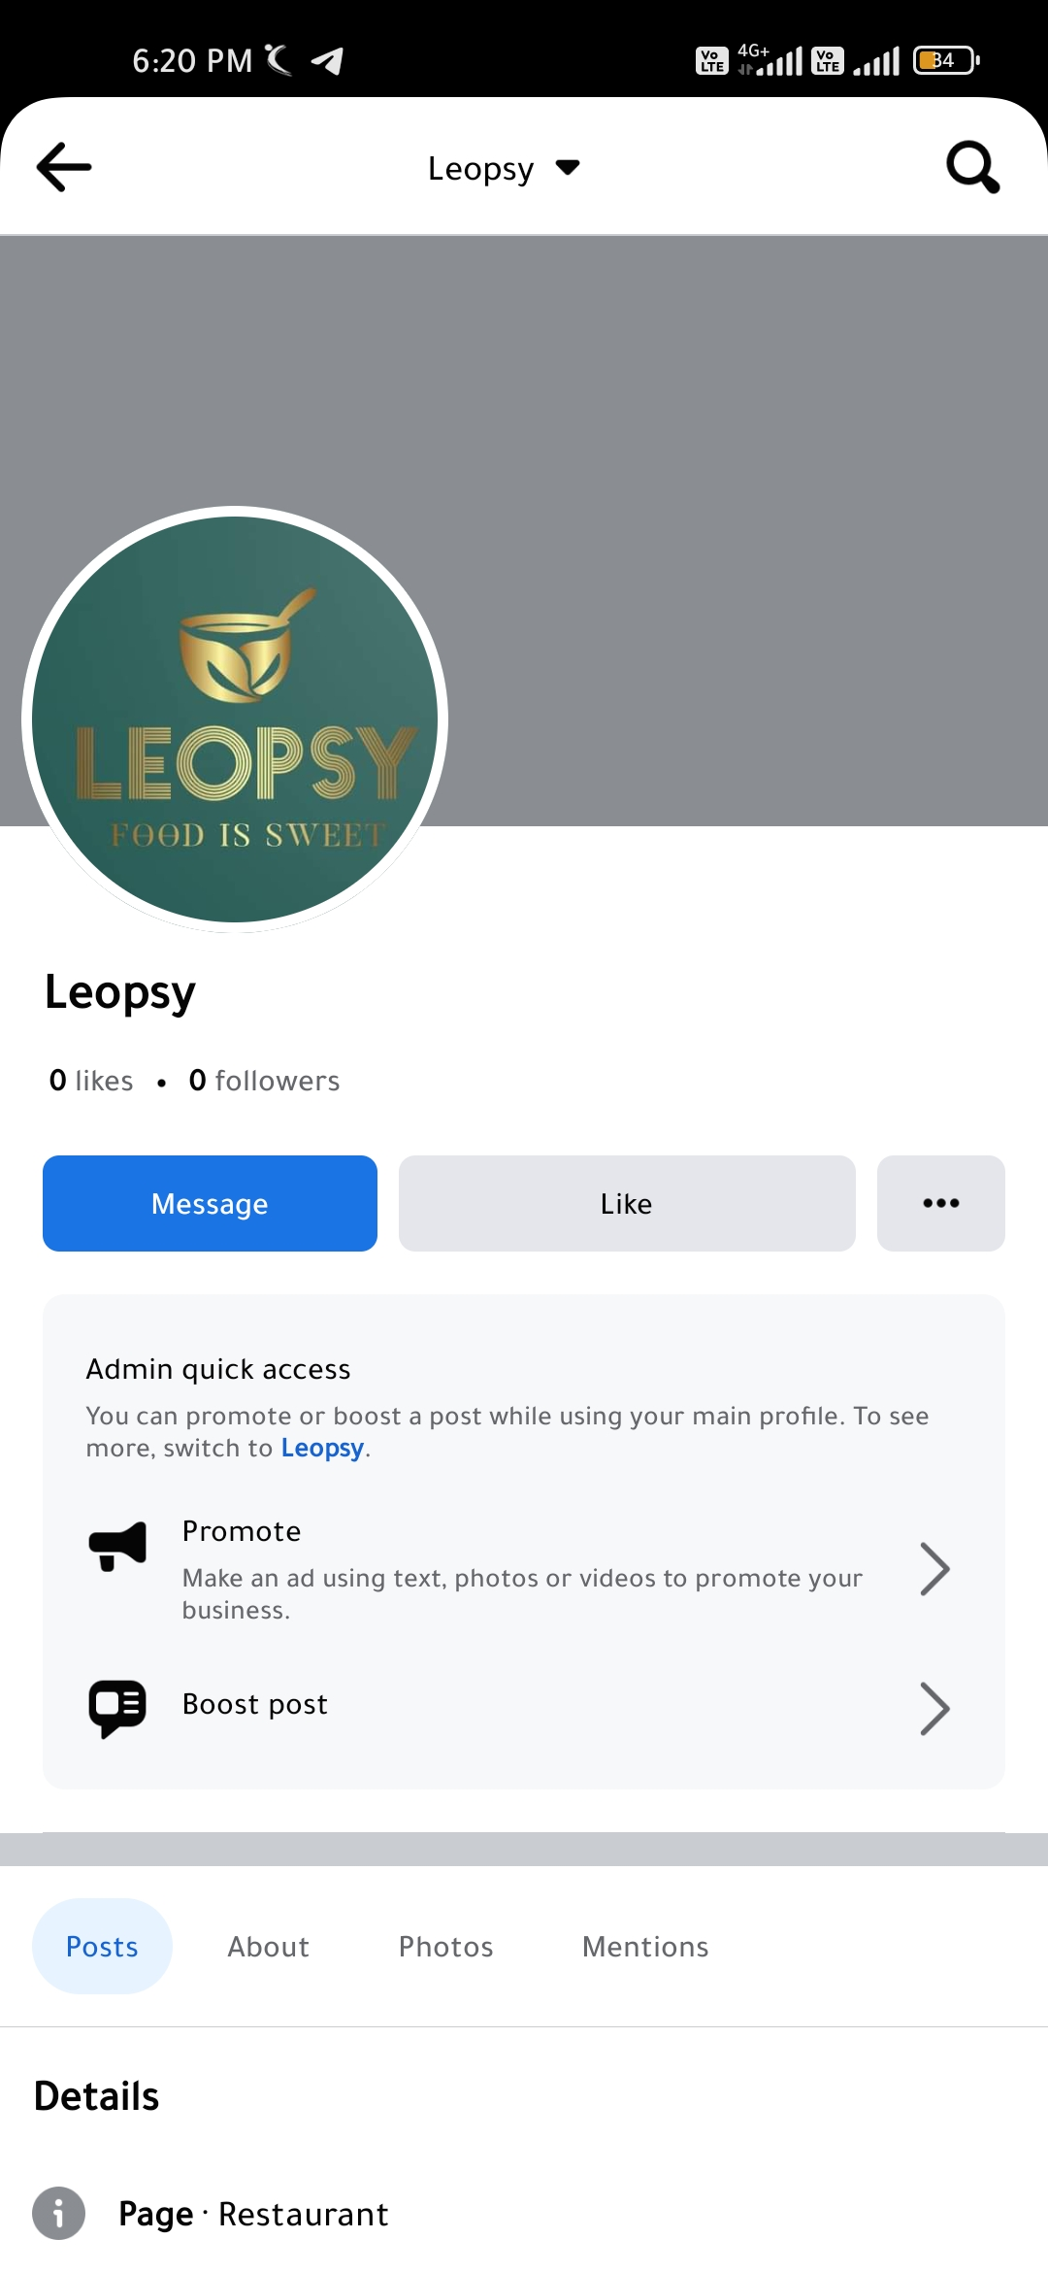**ASSIGNMENT-2**

Create a New Facebook Business Page and Post one social media poster for your brand.

|  |  |
| --- | --- |
| NAME | Harish.C |
| NM ID | 8E0E4FDB6EDE135BC99463BF7F80F082 |
| ASSIGNMENT 2 | Create a New Facebook Business Page and Post one social media poster for your brand |

